PRESS AND PHOTO ACCREDITATION REQUEST
Local, national and international press coverage of the festival is important for us. We appreciate your contribution and we commit to help those who wish to cover the festival in a professional way.
Accredited members of the press receive a “Press” Pass that gives access to the Vivendi VIP Area to meet and speak with artists, organisers and partners of the festival.
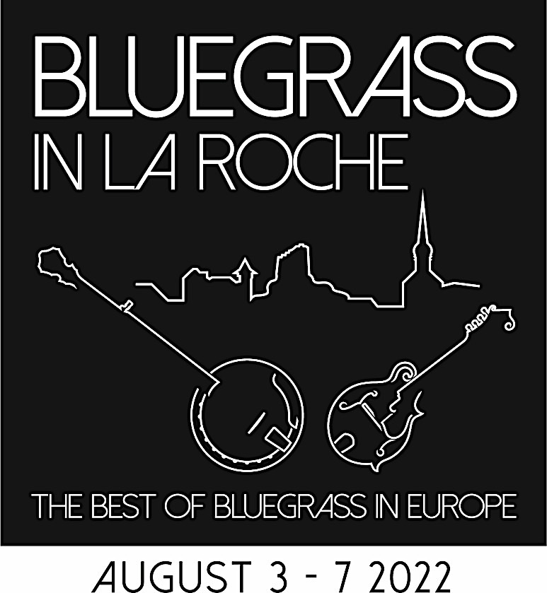
To receive accreditation, please fill in the form below and return it to festival.laroche@gmail.com. Your Press Pass will be available in the Information Chalet on arrival.
In exchange we ask that you share the results of your work with the festival. La Roche Bluegrass Festival will not use your photos for commercial reasons without prior agreement.
Name
Writer or Photographer
Email address
Cell phone
Region or Country

Title of media
Type of media |  | Paper |  | Frequency
 |  | AV |  | Air times
Specialist |  | Web |  | URL
Generalist |  | Other |  | Specify

What coverage will you give to the festival | Before
 | During
 | After
How will you share your work with the festival | PDF by email
 | Link to web page
 | Other

If you require a second pass (press or guest) to the Vivendi VIP tent please state
Name of 2nd person
Relation to you or media

I agree to respect my press commitments to La Roche Bluegrass Festival

Name ___________________________________ Signature _________________________
Please limit you time in the Vivendi tent during periods of large crowds
Note that access to the stage pit is restricted. See over for photography conditions

